**Smart Warehouse – Inventory Management System**

**Summary : -**

Inventory management software is a [computer](https://en.wikipedia.org/wiki/Computer)-based system for tracking [inventory](https://en.wikipedia.org/wiki/Inventory) levels, orders, [sales](https://en.wikipedia.org/wiki/Sales) and deliveries. It can also be used in the [manufacturing](https://en.wikipedia.org/wiki/Manufacturing) industry to create a [work order](https://en.wikipedia.org/wiki/Work_order), [bill of materials](https://en.wikipedia.org/wiki/Bill_of_materials) and other production-related documents. Companies use inventory management software to avoid product overstock and outages. It is a tool for organizing inventory [data](https://en.wikipedia.org/wiki/Data) that before was generally stored in hard-copy form or in spreadsheets.

Inventory Management System’s main idea is to develop a software interface for godowns for managing total transactions of goods and delivers and money management. Users are provided with graphical GUI for accessing historic data. This application provides graphical graphs to view data for easy understanding and managing daily transactions with intake and outgoing data mentioned clearly.

The Advanced Inventory Management system will be capable to automate all inventory, and stock related activities. This system will provide options to maintain products, customer, customer order, purchase order, payment receive from customer, payment to supplier, issuing and receiving of stocks, transfer stocks from one warehouse to another warehouse, generating various inventory related reports. We are trying to work with Osaw Industrial Products Pvt. Ltd., Haryana for the data required for the project.

**Languages/Tools used in the Project :-**

# **Front End : HTML, CSS (Cascading Style Sheets), Bootstarp**

# **Back End : MySql, Php**

# **Tools Used :**

# **MySql Workbench – For creating the Relational ER Model of the project and SQL Table Create Scripts.**

# **Notepad++ (Windows) - For Text-Editing and writing all the code.**

# **TextWrangler (Mac) - For Text-Editing and writing all the code.**

# **XAMPP – PHP development environment. Used for running SQL Queries in PhpMyAdmin and to display php pages.**

**Final ER diagram of the database :-**

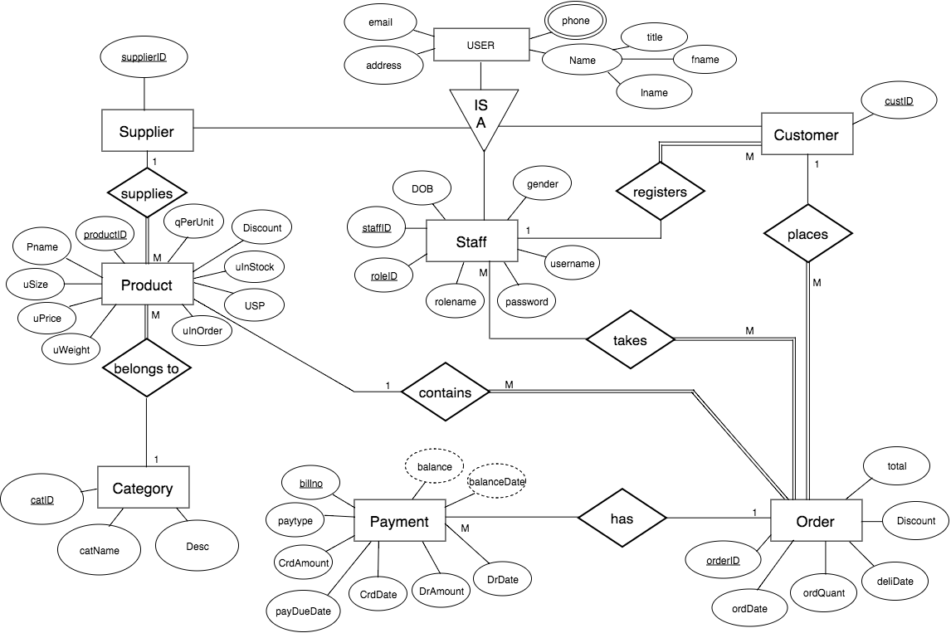

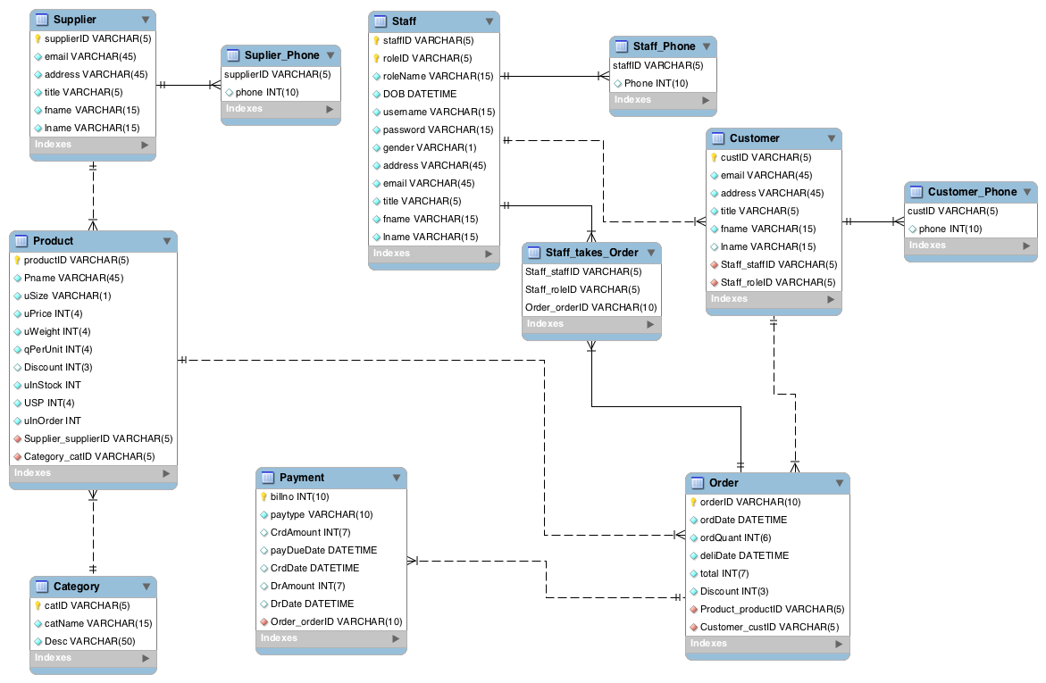

**Snapshot of Front End :-**

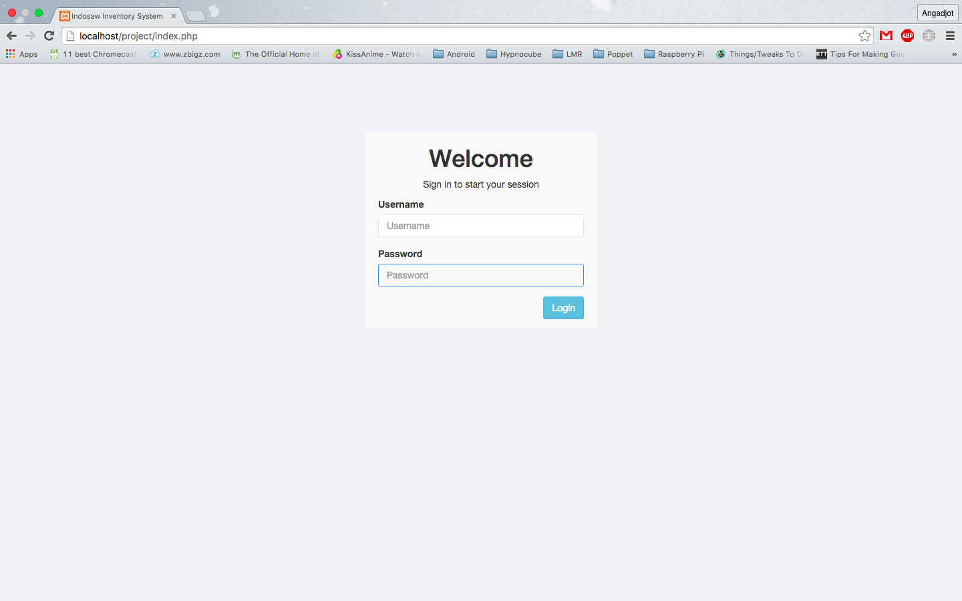

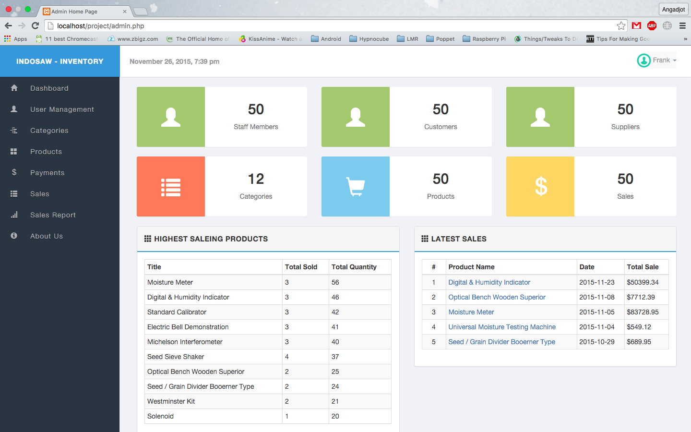

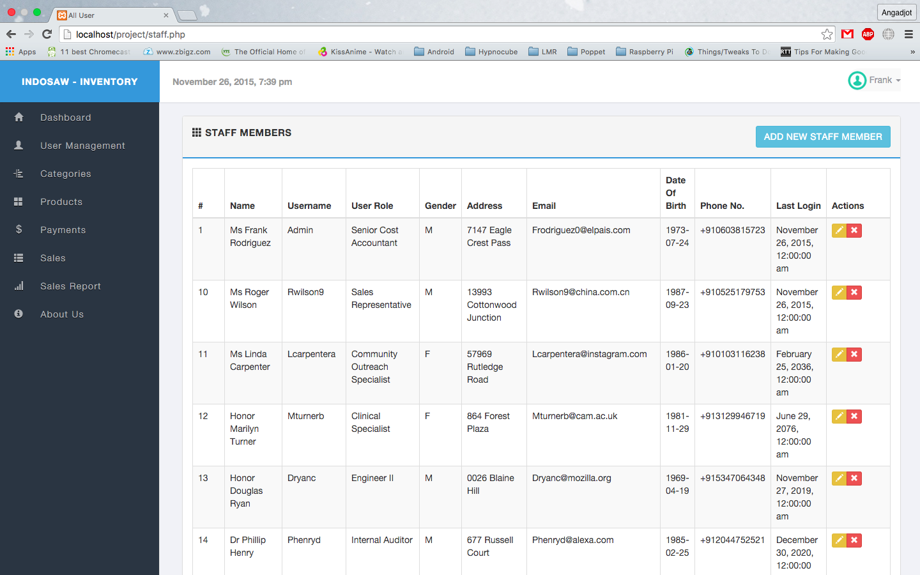

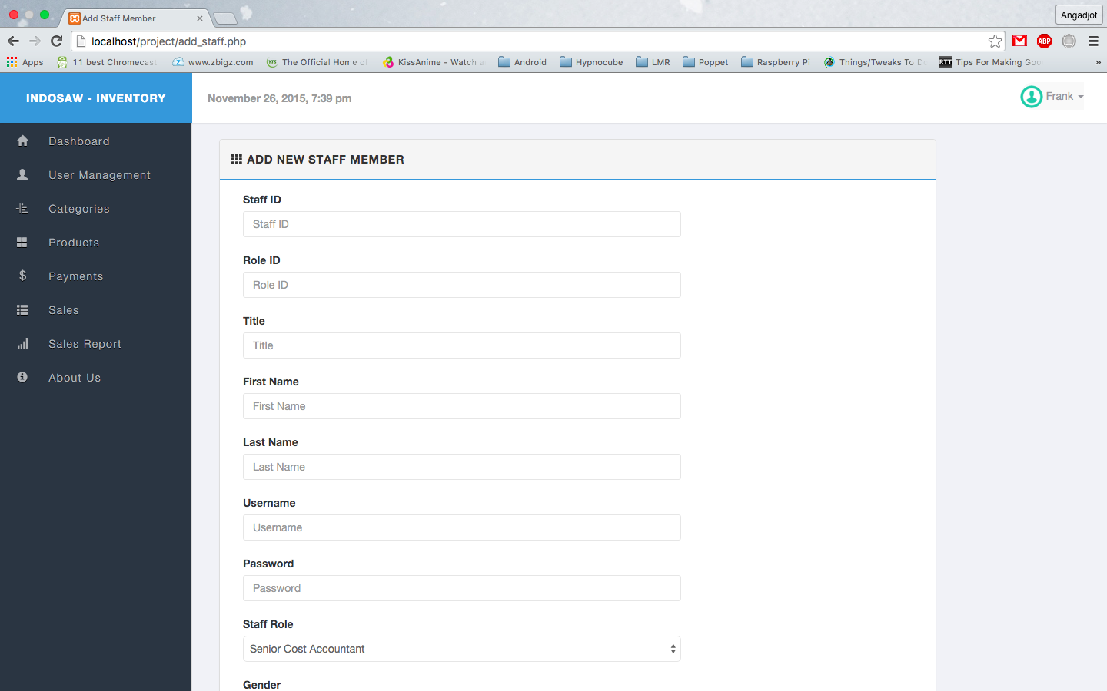

**Need of Project :-**

Existing system works on manual process where record maintenance is not a easy task. In this method it is hard to retrieve older records and there are chances of loosing data. Using this new system can solve all the above problems and provide secure and user friendly application.